NAME: HENG CHHAYHONG

ID: e20190263

GROUP: GIC-A

**TP4 Assignment**

**GIT URL: https://github.com/HengChhayhong275/IP-TP4.git**

**EX1. Tab**

* Design following UI to have 3 tabs.

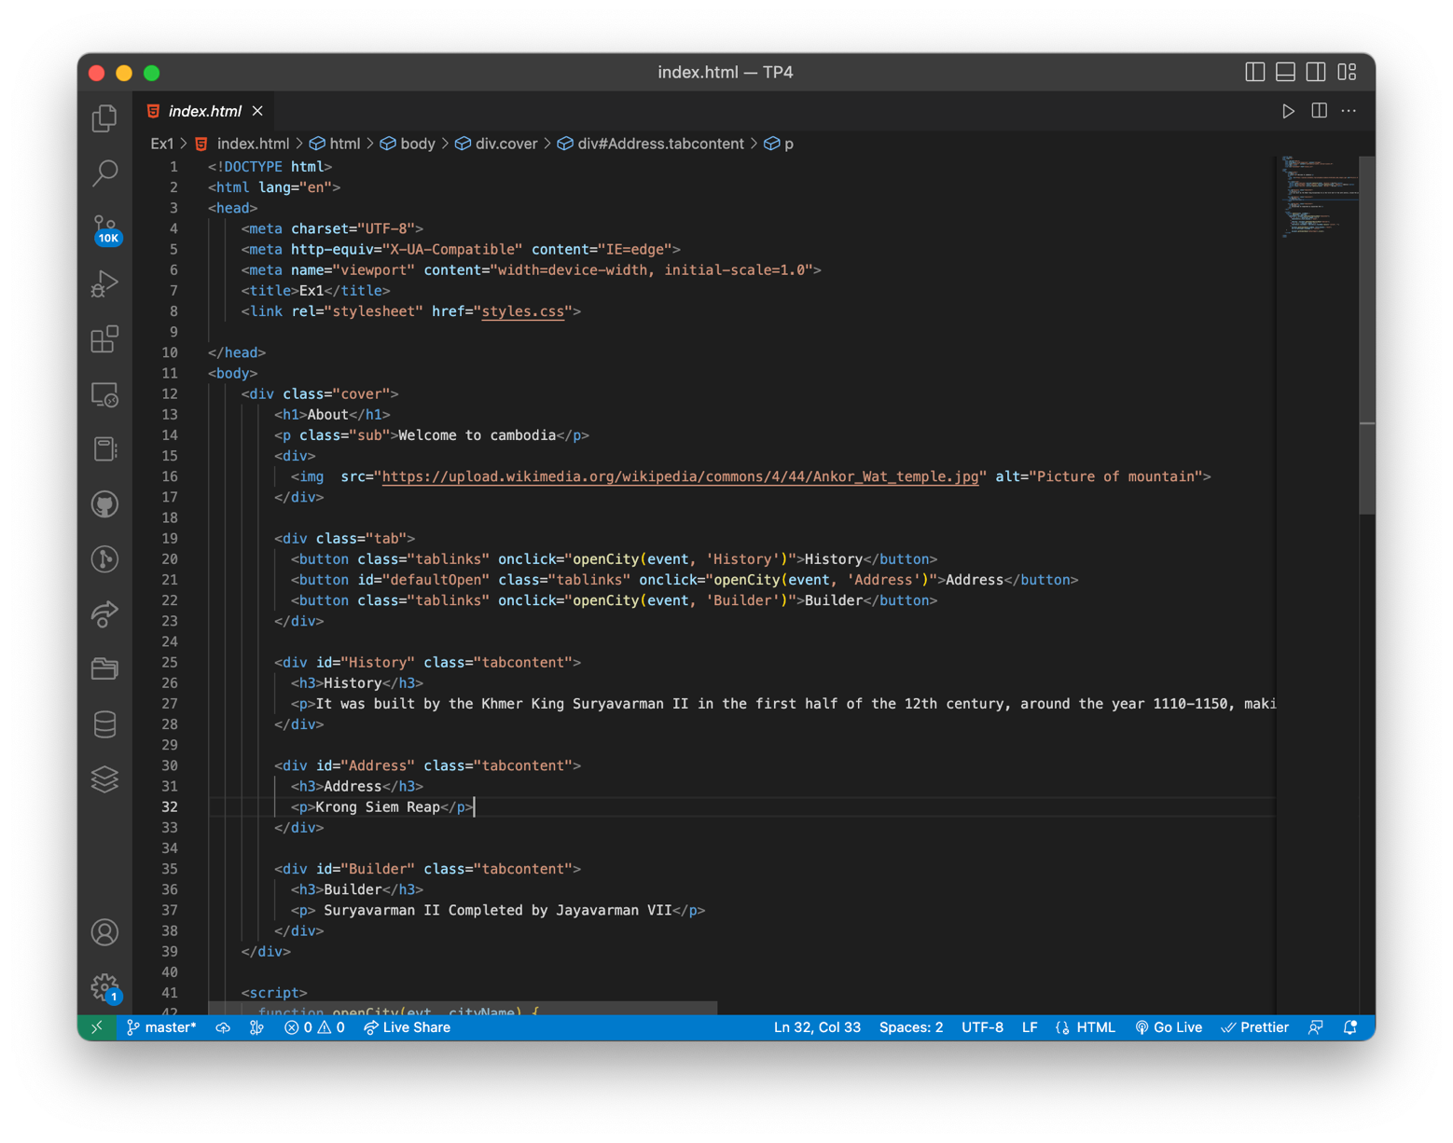

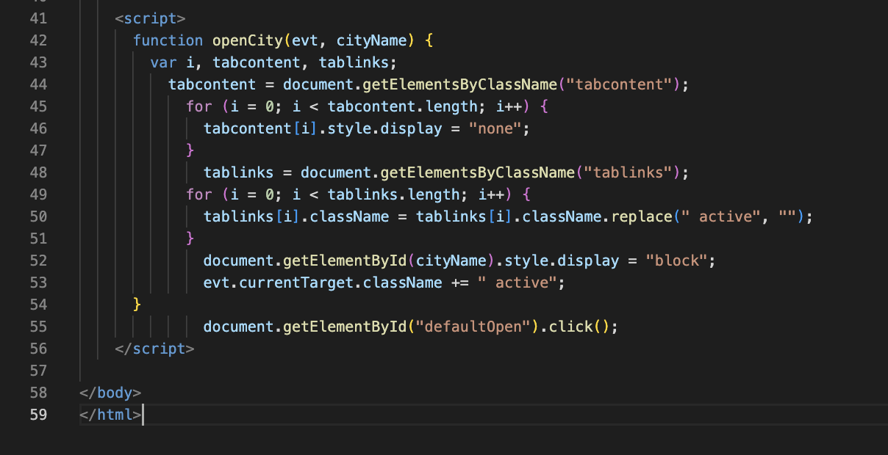

**Output**

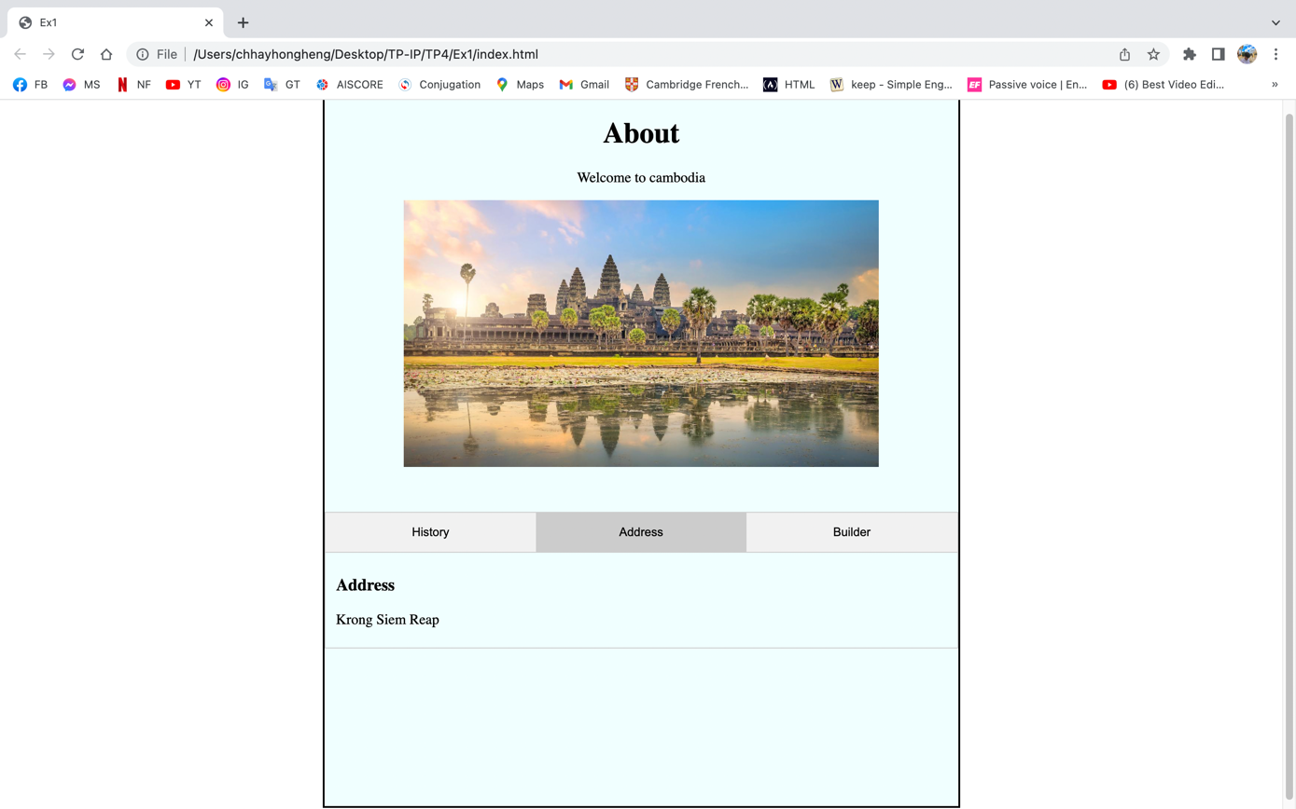

**EX2. Responsive Menu**

* 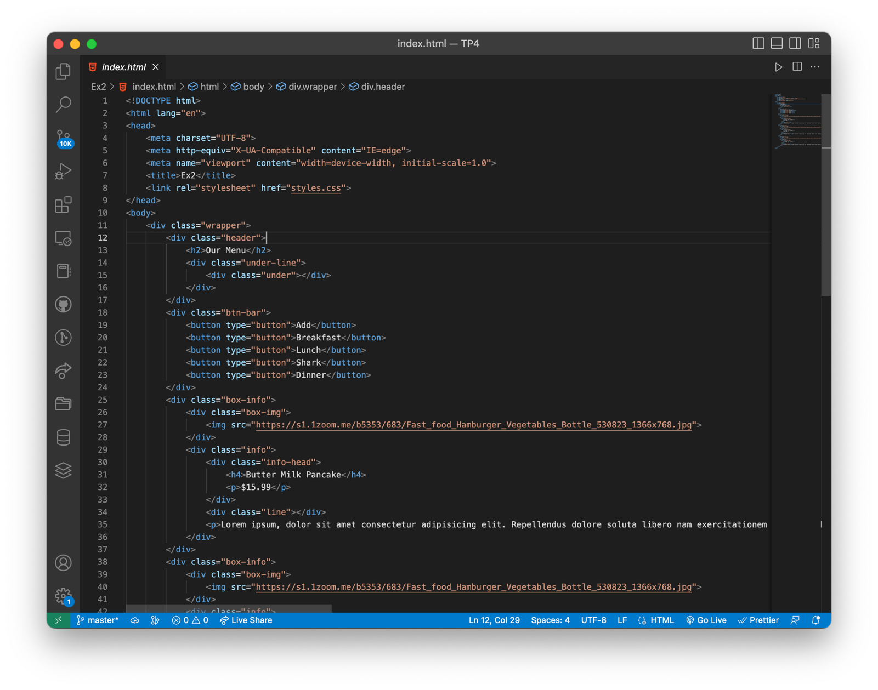Design following responsive UI as following

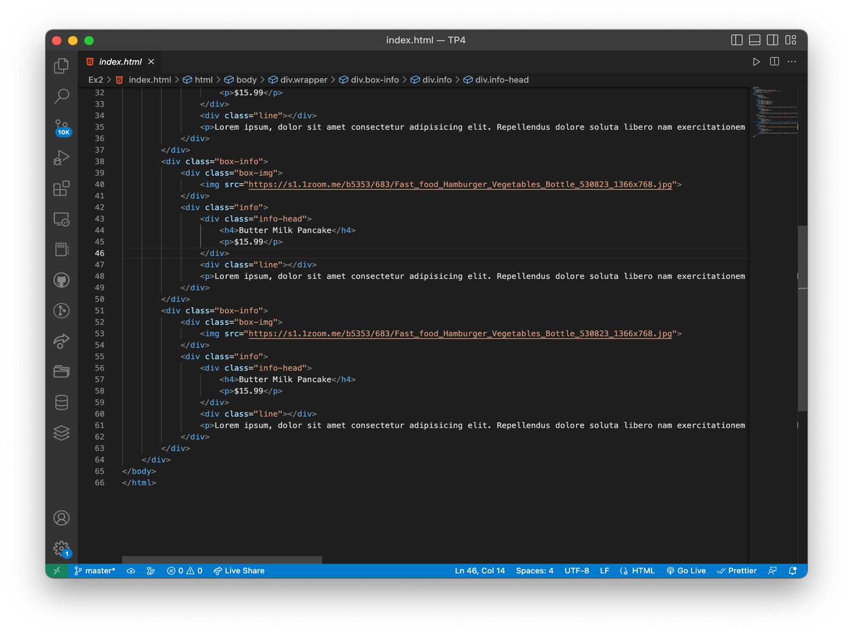

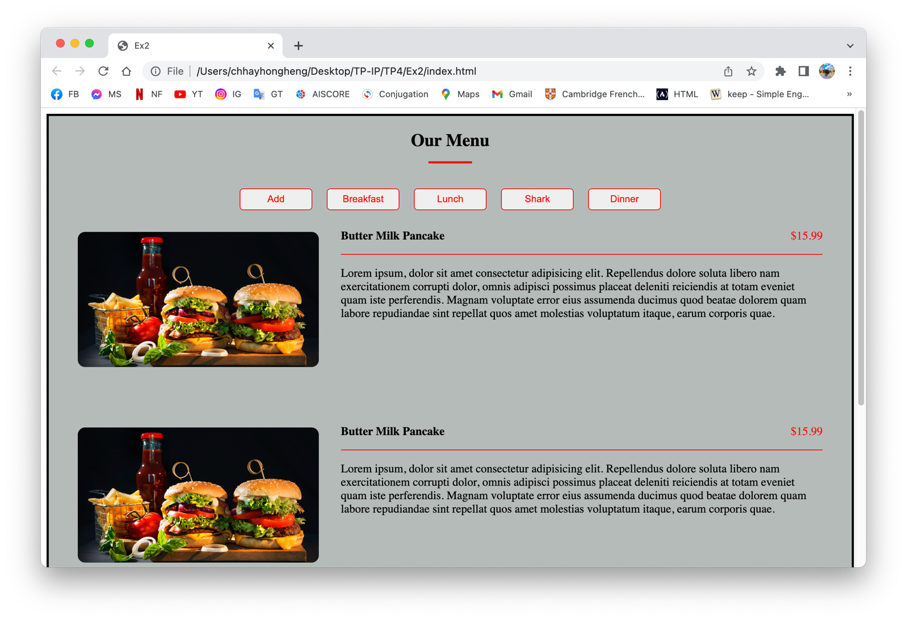**Output**

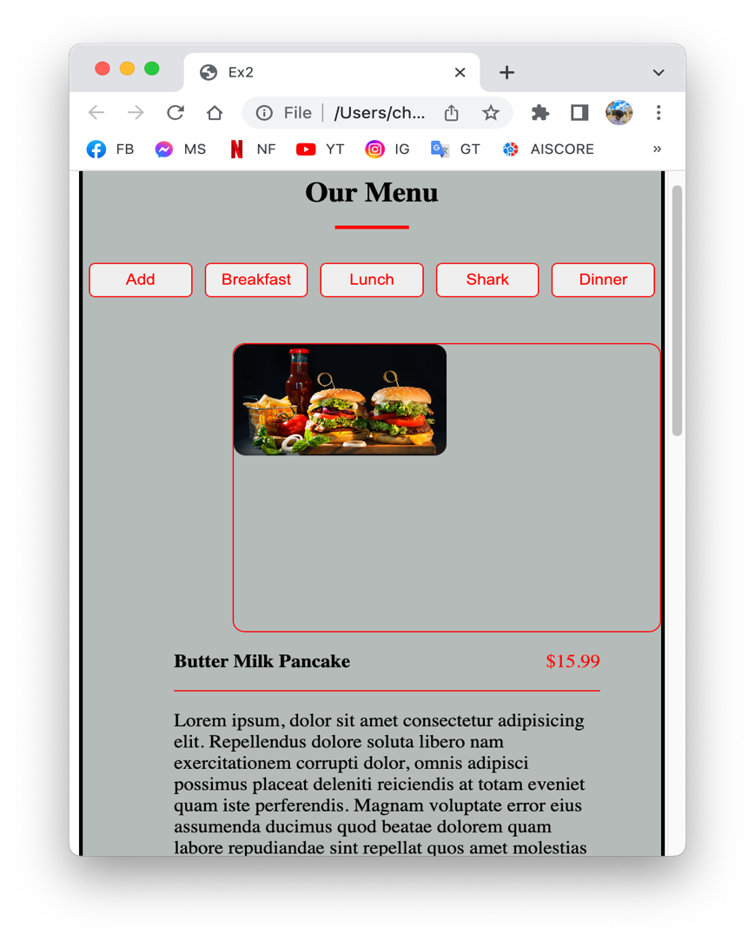**EX3. Counter**

* 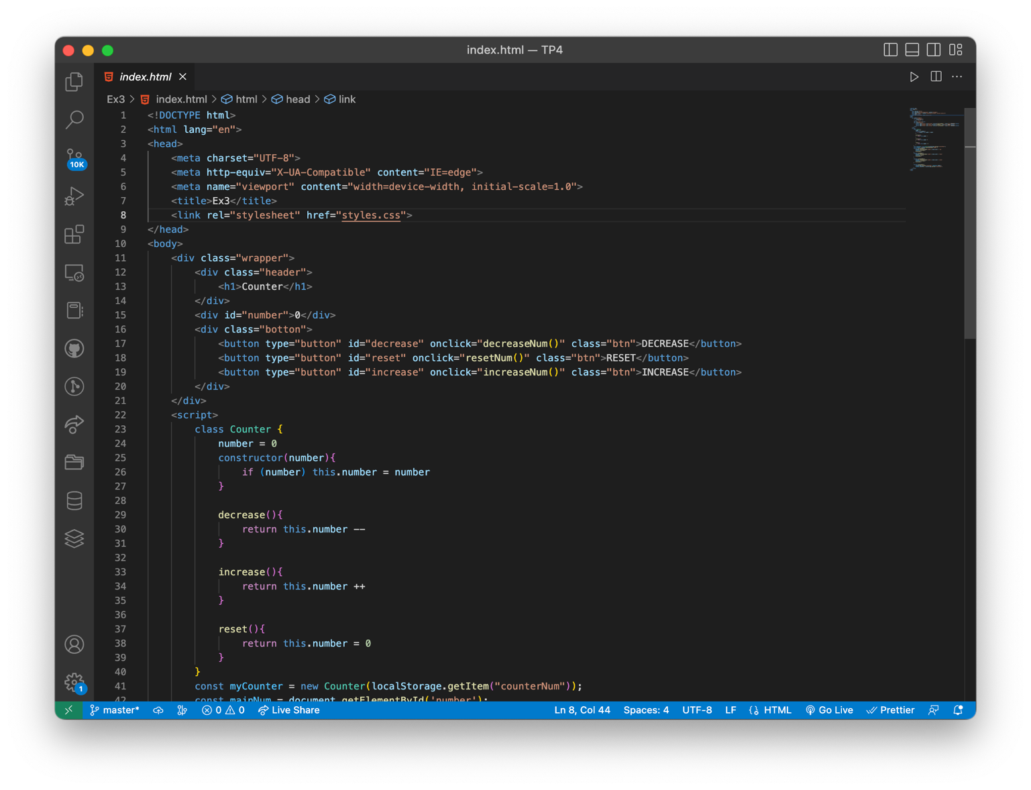Build a number counter app with Class/Object concept and local storage

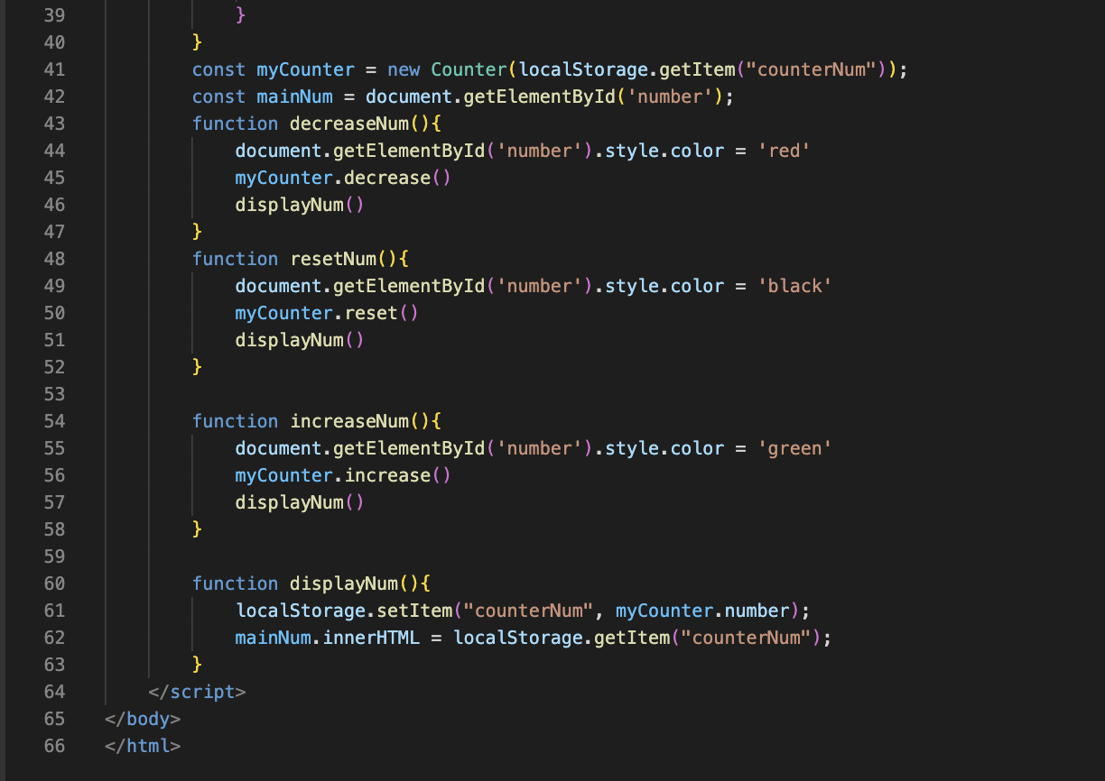

**Output**

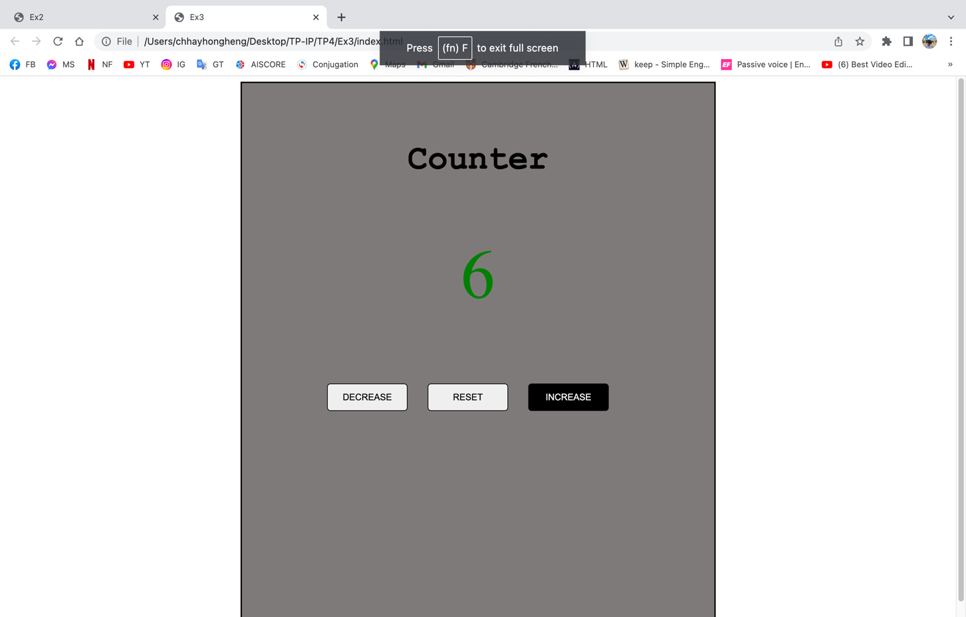

**EX4. Random Color Generator**

* 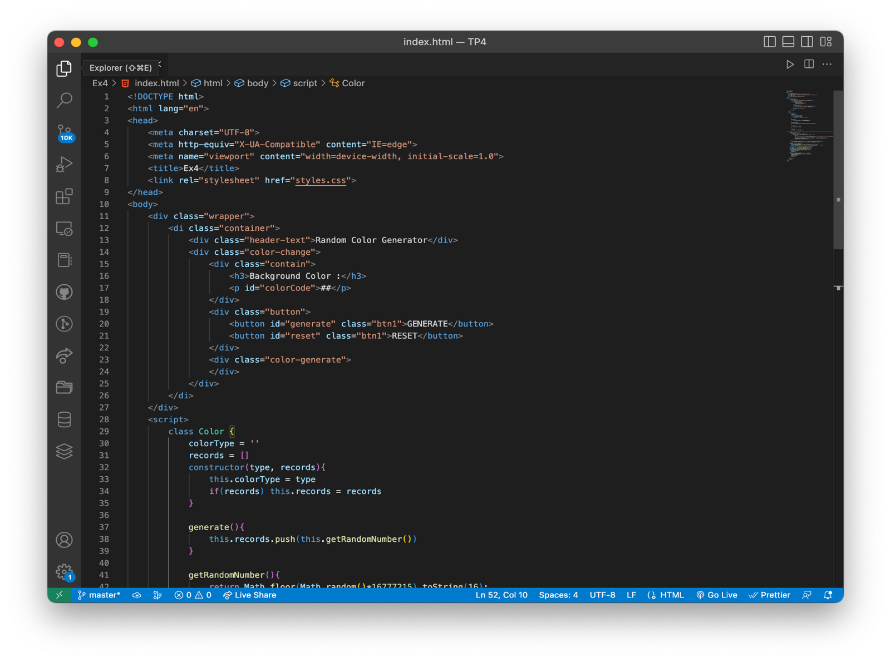Build color generator app with Class/Object concept with local storage

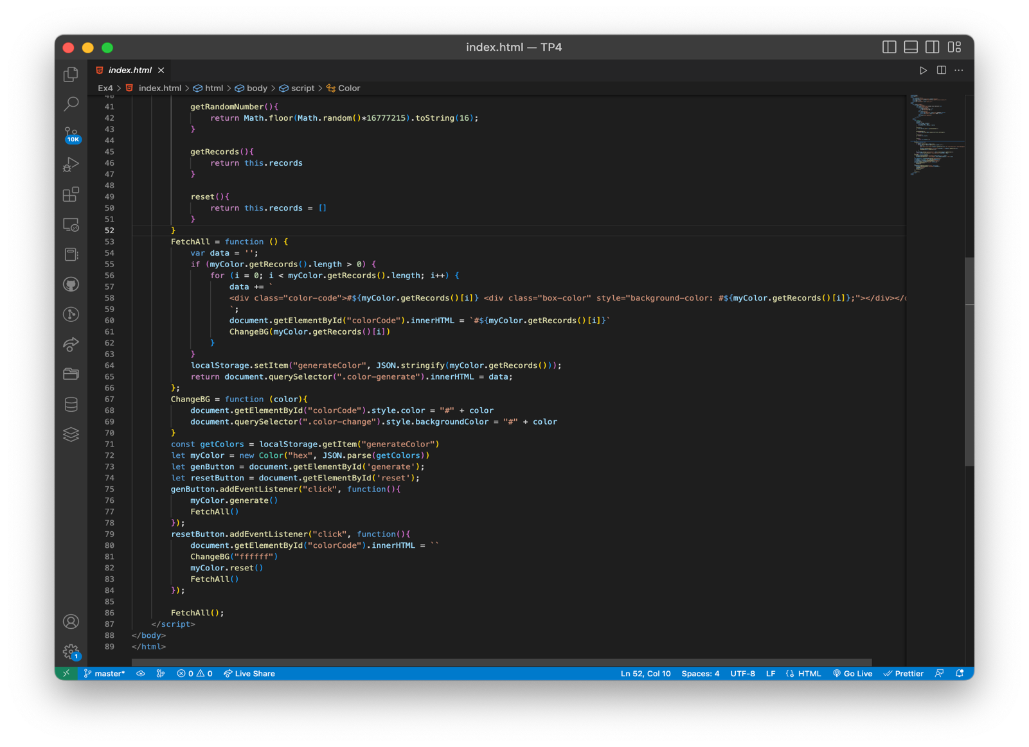

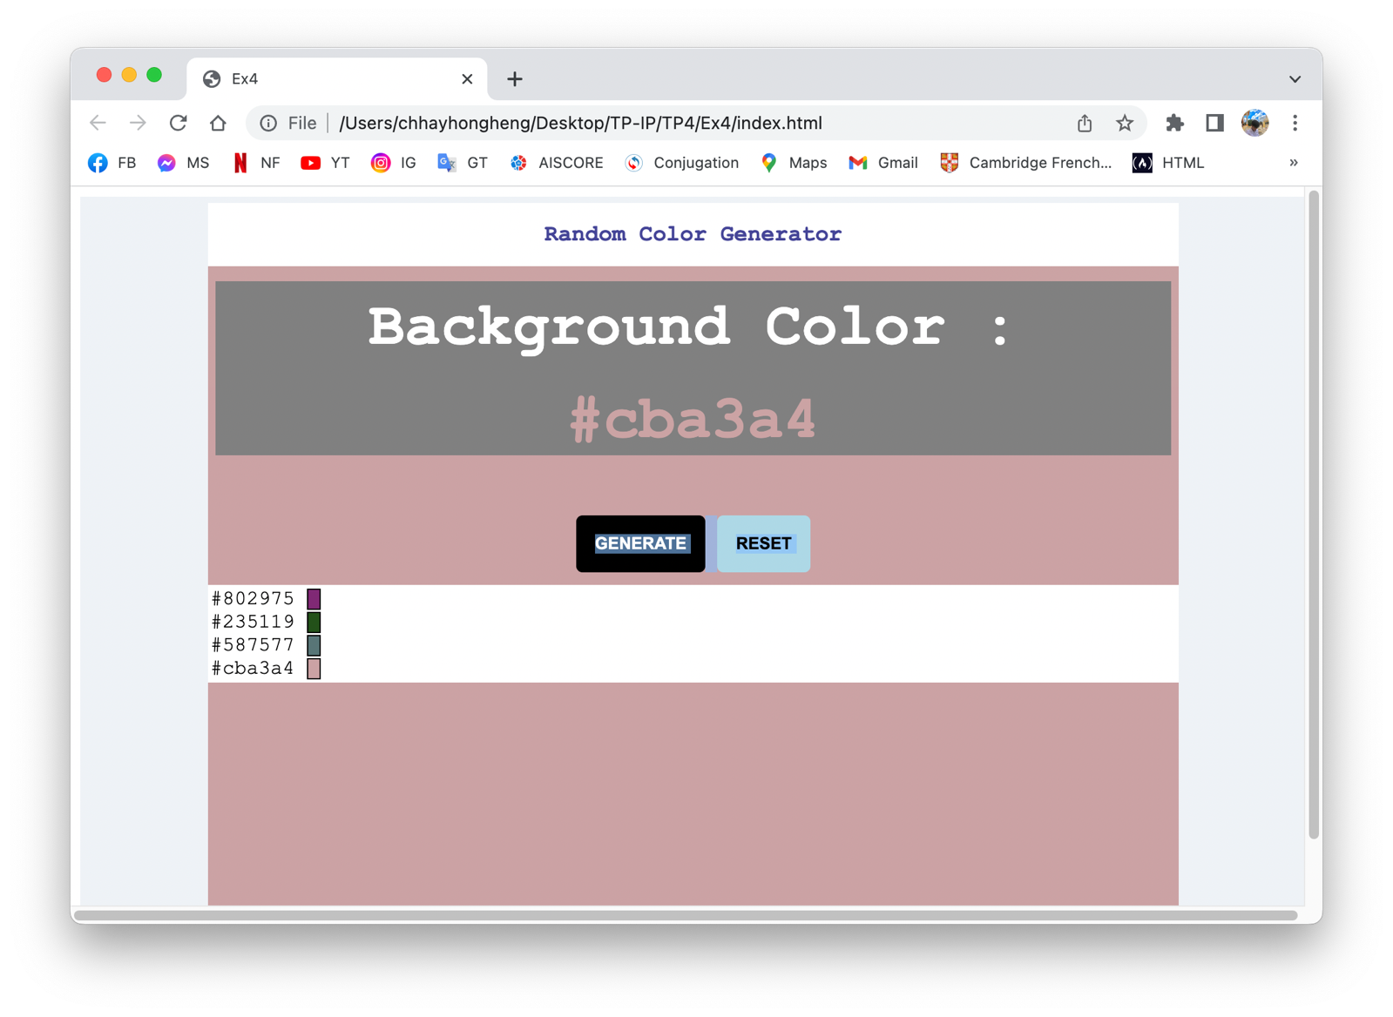**Output**

**EX5. Responsive Navigation Bar**

* 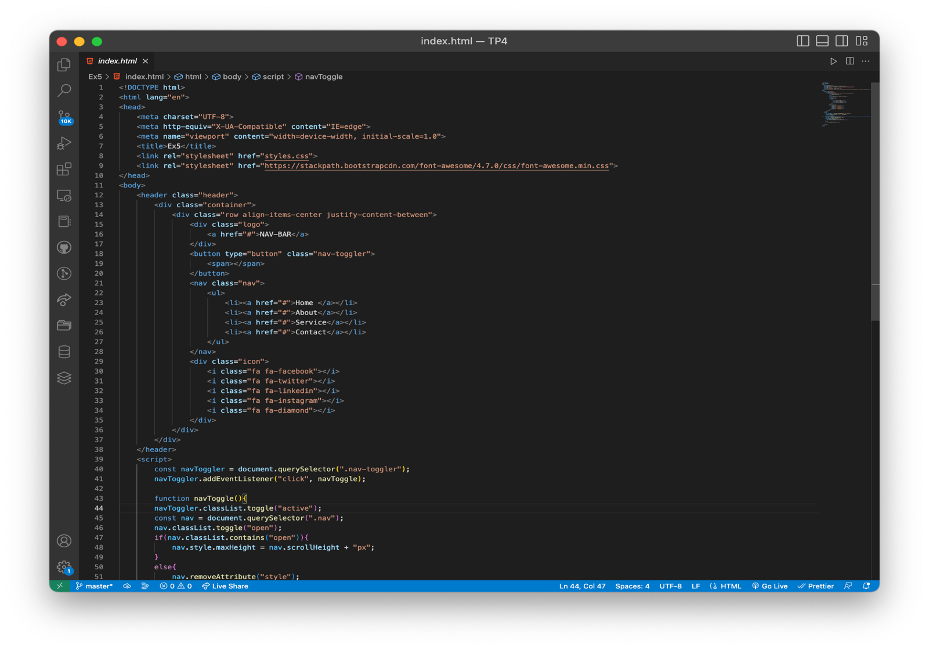Build a navigation bar to support both wide and mobile screen.

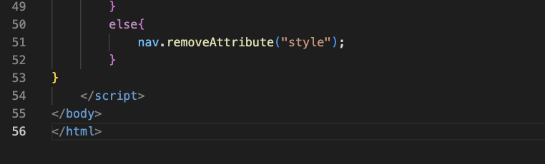

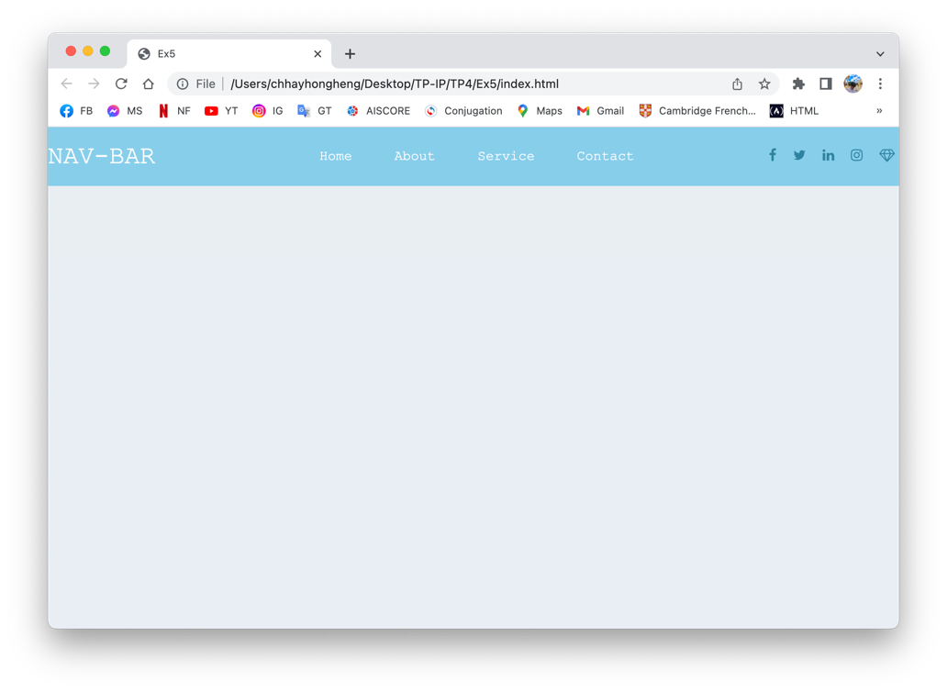**Output**

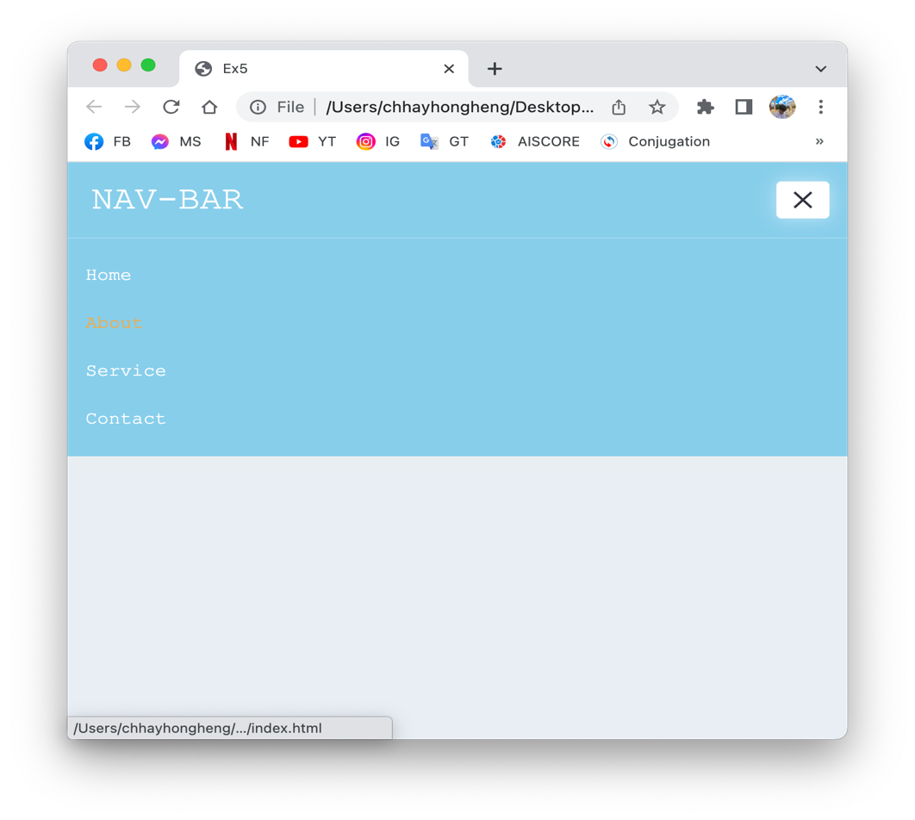

**EX6. Side Bar**

* 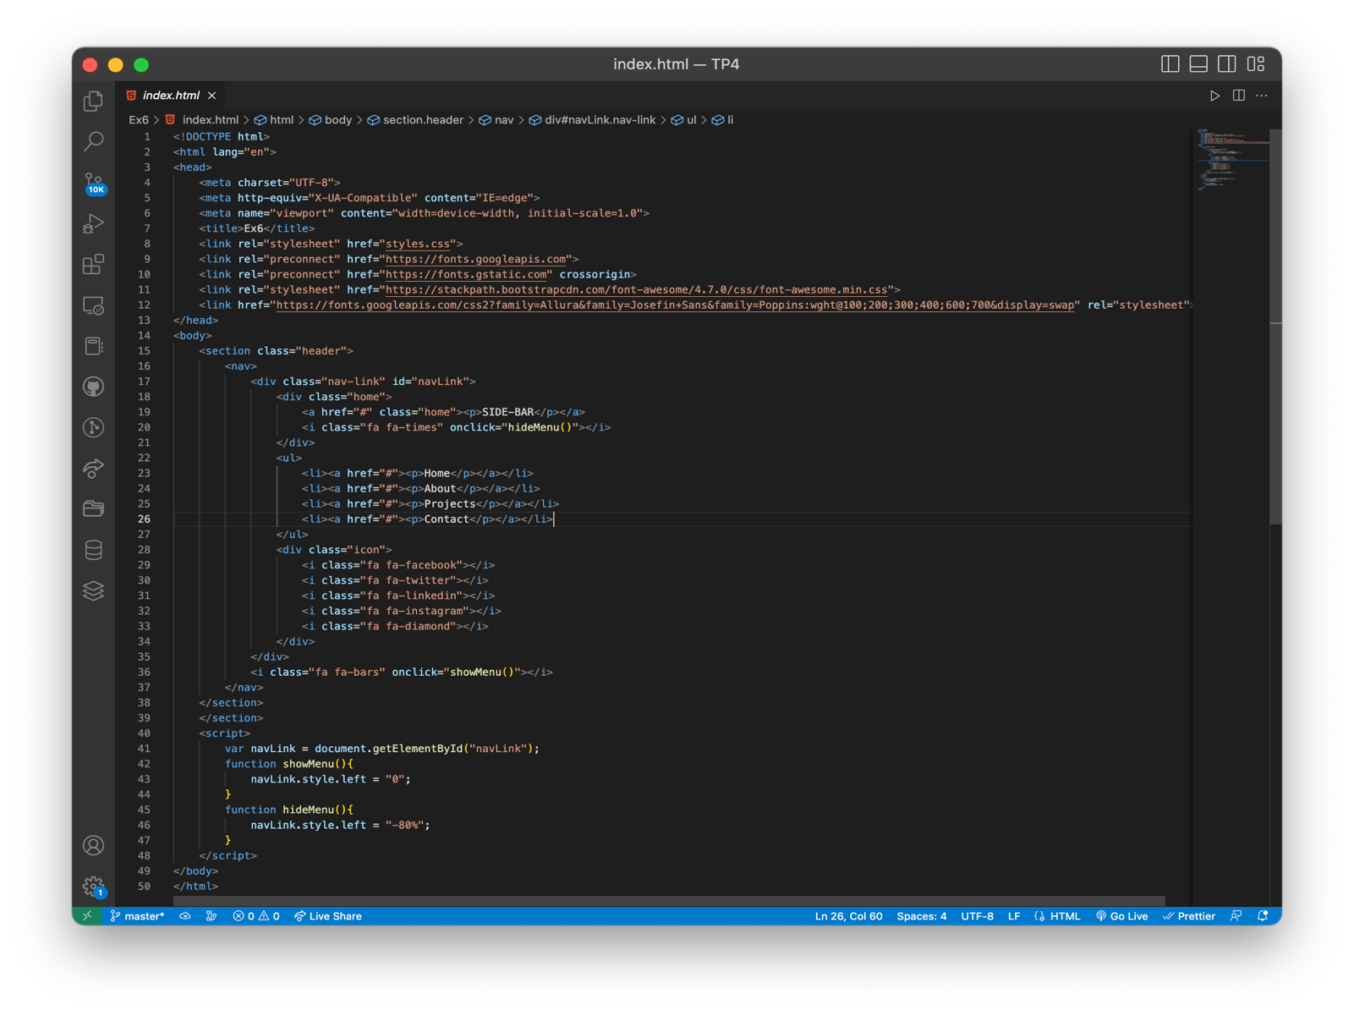Build an app with a side bar

